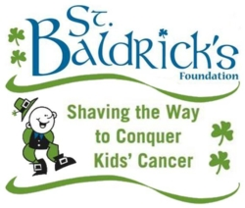
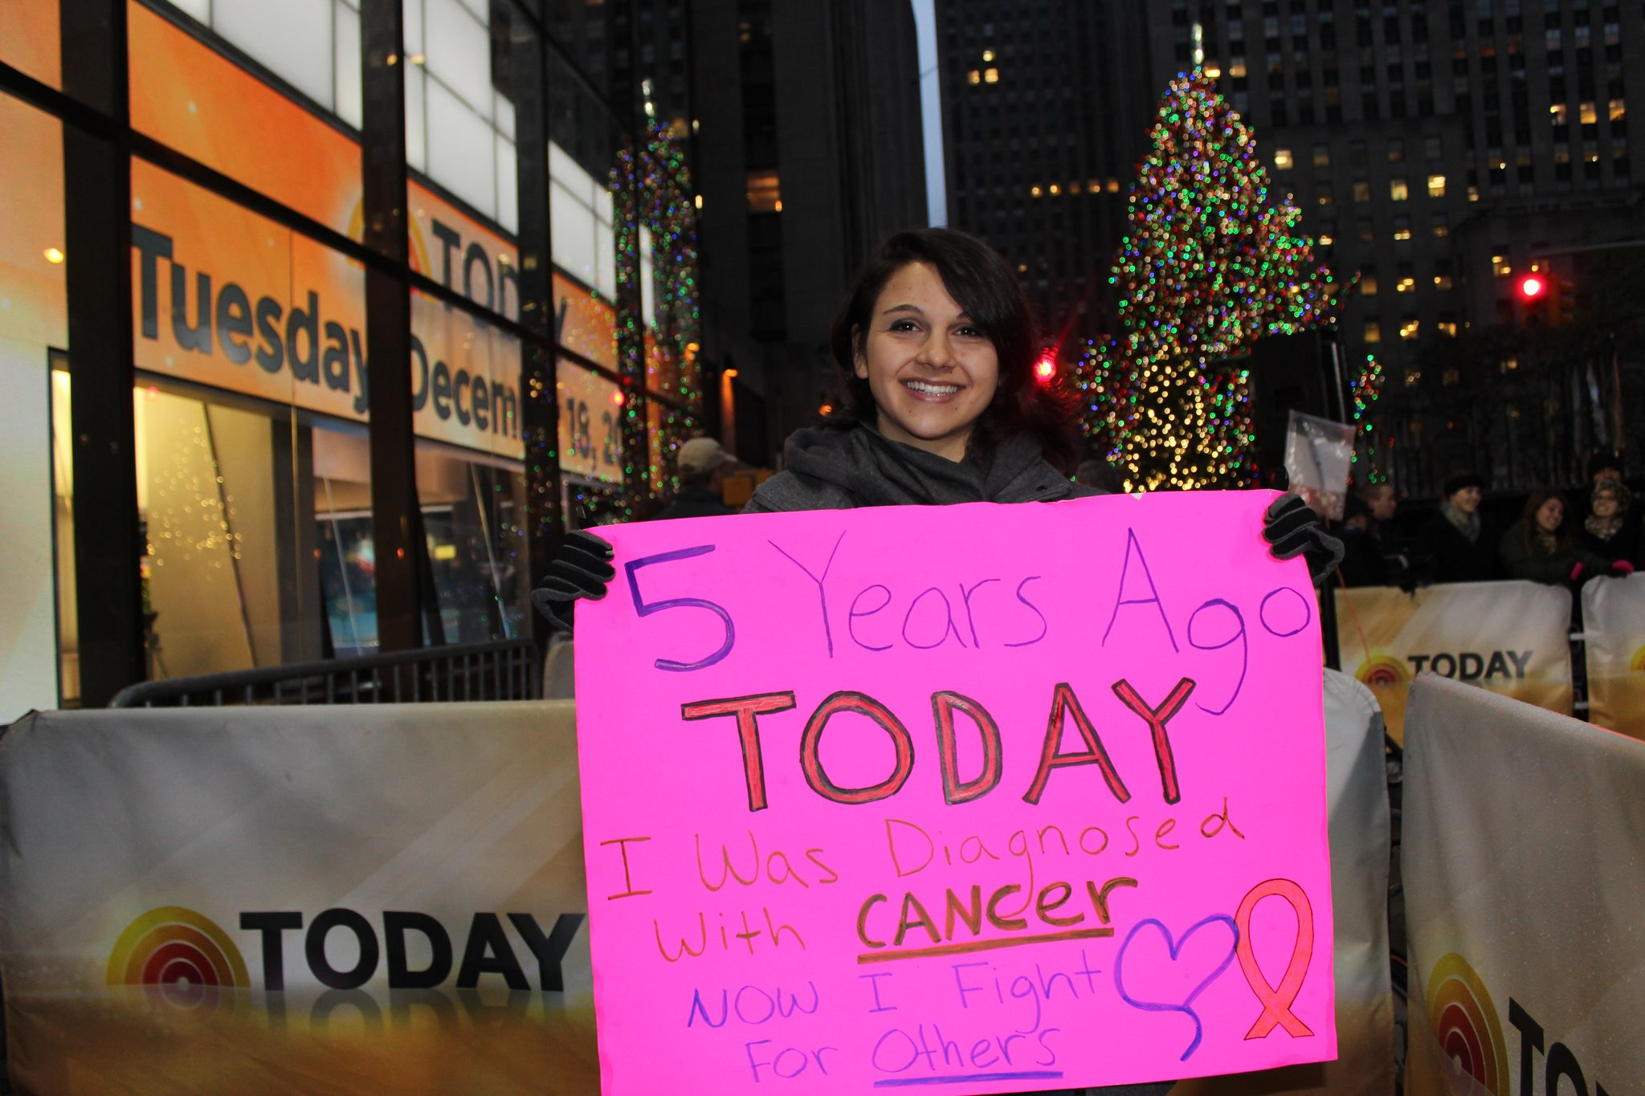
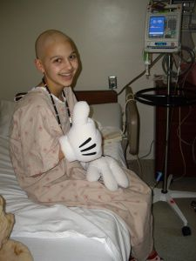
For donation information please visit:

www.stbaldricks.org/participants/melinda
For more information about
St. Baldrick’s, please visit:

www.stbaldricks.org
How you can help!
-Direct donations
-Have your business match donations made
-Donate raffle items
-Spread the word about St. Baldrick’s and my efforts

*”Like a walkathon- but without the blisters”

*Is the #1 private grant provider for childhood cancer research

*Holds yearly shave events worldwide

*Raised over $33 million last year

St. Baldrick’s Foundation:
  - Please support me as I shave my head to raise money for childhood cancer research!

I’m going bald…again!

